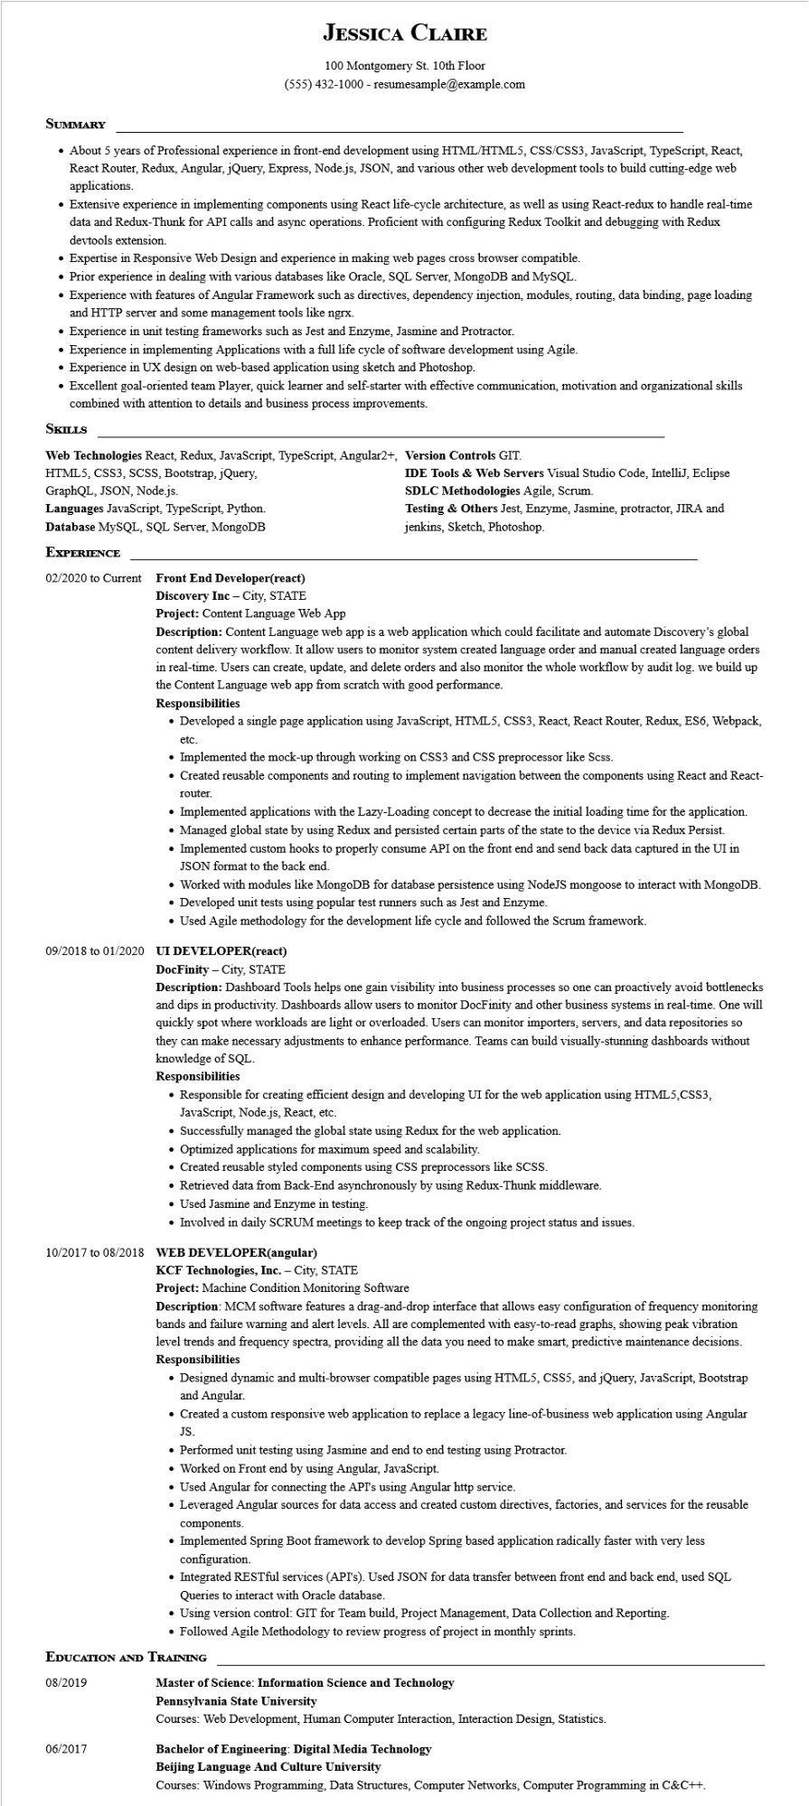
JESSICA CLAIRE
100 Montgomery St. 10th Floor
(555) 432-1000 - resumesample@example.com
SUMMARY
• About 5 years of Professional experience in front-end development using HTML/HTML5, CSS/CSS3, JavaScript, TypeScript, React, React Router, Redux, Angular, jQuery, Express, Node.js, JSON, and various other web development tools to build cutting-edge web applications.
Extensive experience in implementing components using React life-cycle architecture, as well as using React-redux to handle real-time data and Redux-Thunk for API calls and async operations. Proficient with configuring Redux Toolkit and debugging with Redux devtools extension.
• Expertise in Responsive Web Design and experience in making web pages cross browser compatible.
• Prior experience in dealing with various databases like Oracle, SQL Server, MongoDB and MySQL.
• Experience with features of Angular Framework such as directives, dependency injection, modules, routing, data binding, page loading and HTTP server and some management tools like ngrx.
• Experience in unit testing frameworks such as Jest and Enzyme, Jasmine and Protractor.
• Experience in implementing Applications with a full life cycle of software development using Agile.
• Experience in UX design on web-based application using sketch and Photoshop.
• Excellent goal-oriented team Player, quick learner and self-starter with effective communication, motivation and organizational skills combined with attention to details and business process improvements.
SKILLS
Web Technologies React, Redux, JavaScript, TypeScript, Angular2+, Version Controls GIT.
HTML5, CSS3, SCSS, Bootstrap, jQuery,
GraphQL, JSON, Node.js.
Languages JavaScript, TypeScript, Python.
Database MySQL, SQL Server, MongoDB
EXPERIENCE
02/2020 to Current
Front End Developer(react)
IDE Tools & Web Servers Visual Studio Code, IntelliJ, Eclipse SDLC Methodologies Agile, Scrum.
Testing & Others Jest, Enzyme, Jasmine, protractor, JIRA and jenkins, Sketch, Photoshop.
Discovery Inc - City, STATE
Project: Content Language Web App
Description: Content Language web app is a web application which could facilitate and automate Discovery's global content delivery workflow. It allow users to monitor system created language order and manual created language orders in real-time. Users can create, update, and delete orders and also monitor the whole workflow by audit log. we build up the Content Language web app from scratch with good performance.
Responsibilities
• Developed a single page application using JavaScript, HTML5, CSS3, React, React Router, Redux, ES6, Webpack,
etc.
• Implemented the mock-up through working on CSS3 and CSS preprocessor like Scss.
• Created reusable components and routing to implement navigation between the components using React and React-
router.
• Implemented applications with the Lazy-Loading concept to decrease the initial loading time for the application.
• Managed global state by using Redux and persisted certain parts of the state to the device via Redux Persist.
• Implemented custom hooks to properly consume API on the front end and send back data captured in the UI in JSON format to the back end.
• Worked with modules like MongoDB for database persistence using NodeJS mongoose to interact with MongoDB. • Developed unit tests using popular test runners such as Jest and Enzyme.
• Used Agile methodology for the development life cycle and followed the Scrum framework.
09/2018 to 01/2020 UI DEVELOPER(react)
DocFinity - City, STATE
Description: Dashboard Tools helps one gain visibility into business processes so one can proactively avoid bottlenecks and dips in productivity. Dashboards allow users to monitor DocFinity and other business systems in real-time. One will quickly spot where workloads are light or overloaded. Users can monitor importers, servers, and data repositories so they can make necessary adjustments to enhance performance. Teams can build visually-stunning dashboards without knowledge of SQL.
Responsibilities
• Responsible for creating efficient design and developing UI for the web application using HTML5, CSS3, JavaScript, Node.js, React, etc.
• Successfully managed the global state using Redux for the web application.
• Optimized applications for maximum speed and scalability.
• Created reusable styled components using CSS preprocessors like SCSS.
• Retrieved data from Back-End asynchronously by using Redux-Thunk middleware.
• Used Jasmine and Enzyme in testing.
• Involved in daily SCRUM meetings to keep track of the ongoing project status and issues.
10/2017 to 08/2018 WEB DEVELOPER(angular)
KCF Technologies, Inc. - City, STATE
Project: Machine Condition Monitoring Software
Description: MCM software features a drag-and-drop interface that allows easy configuration of frequency monitoring bands and failure warning and alert levels. All are complemented with easy-to-read graphs, showing peak vibration level trends and frequency spectra, providing all the data you need to make smart, predictive maintenance decisions. Responsibilities
• Designed dynamic and multi-browser compatible pages using HTML5, CSS5, and jQuery, JavaScript, Bootstrap and Angular.
• Created a custom responsive web application to replace a legacy line-of-business web application using Angular JS.
• Performed unit testing using Jasmine and end to end testing using Protractor.
• Worked on Front end by using Angular, JavaScript.
• Used Angular for connecting the API's using Angular http service.
• Leveraged Angular sources for data access and created custom directives, factories, and services for the reusable components.
• Implemented Spring Boot framework to develop Spring based application radically faster with very less configuration.
• Integrated RESTful services (API's). Used JSON for data transfer between front end and back end, used SQL Queries to interact with Oracle database.
• Using version control: GIT for Team build, Project Management, Data Collection and Reporting.
• Followed Agile Methodology to review progress of project in monthly sprints.
EDUCATION AND TRAINING
08/2019
06/2017
Master of Science: Information Science and Technology
Pennsylvania State University
Courses: Web Development, Human Computer Interaction, Interaction Design, Statistics.
Bachelor of Engineering: Digital Media Technology
Beijing Language And Culture University
Courses: Windows Programming, Data Structures, Computer Networks, Computer Programming in C&C++.

